**Description:**

The data set here is about some cereals or morning breakfasts. The goal here is simply to cluster the breakfast items, find the correlation between them, and suggest preferable diets for people with particular cases

**Attribute of the Dataset:**

* 1. Column: Name of cereal
  2. Calories: calories per serving
  3. Protein: grams of protein
  4. Fat: grams of fat
  5. Sodium: milligrams of sodium
  6. Fiber: grams of dietary fiber
  7. Carbo: grams of complex carbohydrates
  8. Sugars: grams of sugars
  9. Potass: milligrams of potassium
  10. Vitamins: vitamins and minerals - 0, 25, or 100, indicating the typical percentage of FDA recommended
  11. Shelf: display shelf (1, 2, or 3, counting from the floor)
  12. Rating: a rating of the cereals (calculated by Consumer Reports)

**Source of the Dataset:**

With Vitamin and rating columns – 77x 11.

**Link:** <http://www.cs.umd.edu/hcil/hce/examples/cereal/cereal-updated.txt>

**DataSet:**

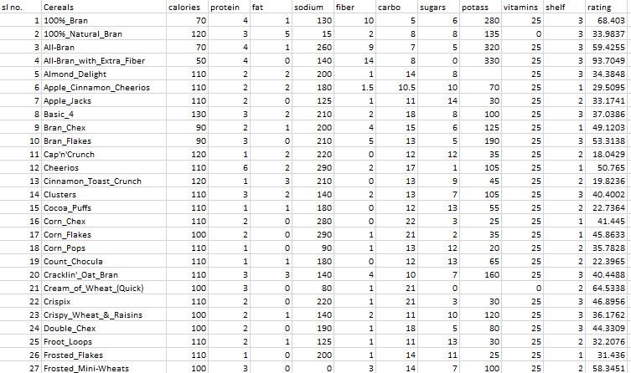

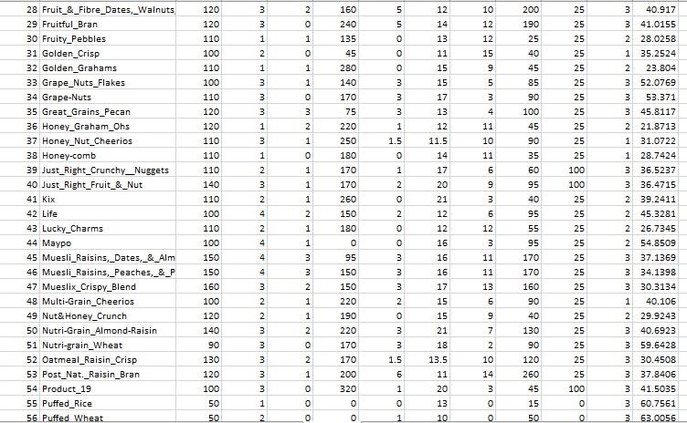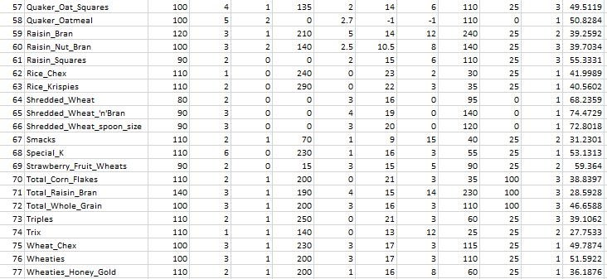

**Instance:** 77

**Attribute:** 11 (Calories, protein, fat, sodium, fiber, carbo, sugars, potass, vitamins, shelf, rating).

**Result:**

=== Clustering model (full training set) ===

Cluster 0

(((((68.402973:1.10054,59.425505:1.10054):0.10318,93.704912:1.20372):0.00394,((33.983679:1.18551,(((((((((((((((((((34.384843:1.04527,((40.400208:1.0182,39.7034:1.0182):0.01535,40.448772:1.03354):0.01172):0.00272,((37.038562:1.02239,40.69232:1.02239):0.0165,30.450843:1.03889):0.00909):0.00251,36.176196:1.05049):0.00012,((52.076897:1.0288,49.511874:1.0288):0.01051,(53.371007:1.02253,59.642837:1.02253):0.01678):0.0113):0.00068,((46.895644:1.03613,39.106174:1.03613):0.00052,44.330856:1.03665):0.01464):0.00489,40.917047:1.05619):0.00924,45.811716:1.06543):0.01267,((37.136863:1.01544,34.139765:1.01544):0.03775,30.313351:1.05318):0.02493):0.00027,(41.015492:1.06917,37.840594:1.06917):0.00921):0.02311,53.313813:1.10149):0.01878,39.241114:1.12027):0.00862,(((((((33.174094:1.0218,32.207582:1.0218):0.00378,(((22.736446:1.00051,22.396513:1.00051):0.0167,(28.025765:1.00013,27.753301:1.00013):0.01709):0.00586,26.734515:1.02308):0.0025):0.00072,31.230054:1.0263):0.00524,29.924285:1.03154):0.00559,35.782791:1.03713):0.00002,((18.042851:1.00627,21.871292:1.00627):0.02532,19.823573:1.03159):0.00556):0.02135,23.804043:1.0585):0.07039):0.00286,((((29.509541:1.0593,((49.120253:1.02913,(40.105965:1.02293,36.187559:1.02293):0.0062):0.0191,(49.787445:1.00479,51.592193:1.00479):0.04344):0.01106):0.00376,31.072217:1.06307):0.00389,(31.435973:1.00563,28.742414:1.00563):0.06133):0.0441,(((41.445019:1.00106,40.560159:1.00106):0.01083,45.863324:1.01189):0.01844,41.998933:1.03033):0.08073):0.0207):0.00478,39.259197:1.13653):0.00225,(((58.345141:1.03393,59.363993:1.03393):0.06049,54.850917:1.09442):0.03167,55.333142:1.12609):0.0127):0.00335,45.328074:1.14213):0.00032,64.533816:1.14245):0.00298,35.252444:1.14544):0.02045,(68.235885:1.0421,(74.472949:1.00566,72.801787:1.00566):0.03644):0.12378):0.01963):0.01049,(60.756112:1.03632,63.005645:1.03632):0.15969):0.01166):0.00284,(50.764999:1.11525,53.131324:1.11525):0.09525):0.05173,(((((36.523683:1.04118,38.839746:1.04118):0.03469,46.658844:1.07587):0.01161,36.471512:1.08748):0.02516,41.50354:1.11264):0.0535,28.592785:1.16614):0.09609)

Time taken to build model (full training data): 0.02 seconds

=== Model and evaluation on training set ===

Clustered Instances

0 76 (99%)

1 1 (1%)

**Tree with Pruning:**

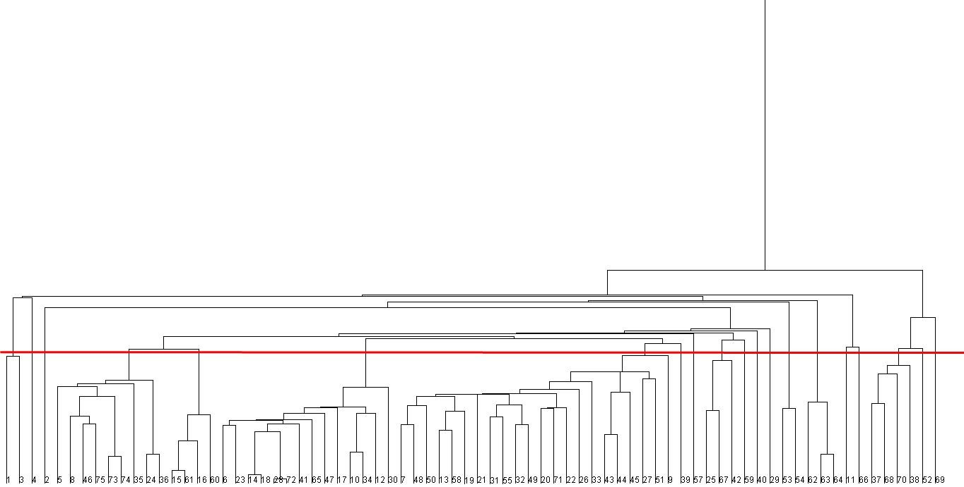

**Cluster Analysis:**

Attributes are split according to:

|  |  |  |  |
| --- | --- | --- | --- |
| Name | High | Medium | Low |
| Calorie | 131-160 | 90-130 | 50-90 |
| Protein | 5-6 | 2-4 | 1-2 |
| Fat | 4-5 | 2-3 | 0-1 |
| Sodium | 211-320 | 111-210 | 0-110 |
| Fiber | 10-14 | 5-9 | 0-4 |
| Carbo | 15-23 | 8-14 | 0-7 |
| Sugar | 11-15 | 6-10 | 0-5 |
| Potassium | 221-330 | 111-220 | 15-110 |
| vitamins | 67-100 | 25-66 | 0-24 |

**Cluster 1: (2 instance)**

High: Potassium

Medium: Protein, Sodium, Fiber and Vitamin

Low: Calories, Fat, Carbo and Sugar

|  |  |  |  |  |  |  |  |  |  |  |
| --- | --- | --- | --- | --- | --- | --- | --- | --- | --- | --- |
| Cereal  Name | calories | protein | fat | sodium | fiber | carbo | sugars | potass | vitamin s | Rating |
| 100%_Bran | 70 | 4 | 1 | 130 | 10 | 5 | 6 | 280 | 25 | 68.4029  7 |
| All-Bran | 70 | 4 | 1 | 260 | 9 | 7 | 5 | 320 | 25 | 59.4255  1 |

**Cluster 2: (1 instance)**

High: Potassium and Fiber

Medium: Protein, Sodium, Carbo and Vitamin

Low: Sugar, Fat and Calories

|  |  |  |  |  |  |  |  |  |  |  |
| --- | --- | --- | --- | --- | --- | --- | --- | --- | --- | --- |
| Cereal  Name | calories | protei n | fat | sodium | fiber | carbo | sugars | potass | vitamin s | Rating |
| All-Bran_ with_Extra _Fiber | 50 | 4 | 0 | 140 | 14 | 8 | 0 | 330 | 25 | 93.704  91 |

**Cluster 3: (1 instance)**

High: Fat

Medium: Potassium, Sugar, Calories, Protein and Carbo

Low: Sodium, Fiber and Vitamin

|  |  |  |  |  |  |  |  |  |  |  |
| --- | --- | --- | --- | --- | --- | --- | --- | --- | --- | --- |
| Cereal  Name | calo ries | protein | fat | sodium | fiber | carbo | sugars | potass | vitamin s | Rating |
| 100%_Natu ral_Bran | 120 | 3 | 5 | 15 | 2 | 8 | 8 | 135 | 0 | 33.983  68 |

**Cluster 4: (9 instance)**

High: Carbo

Medium: Calories, Fat, Protein, Sodium, Sugar, Vitamin

Low: Fiber, Potass

|  |  |  |  |  |  |  |  |  |  |  |
| --- | --- | --- | --- | --- | --- | --- | --- | --- | --- | --- |
| Cereal  Name | calorie s | protein | fat | sodium | fiber | carbo | sugars | potass | vitamins | Rating |
| Almond_D  elight | 110 | 2 | 2 | 200 | 1 | 14 | 8 | 25 | 25 | 34.38484 |
| Basic_4 | 130 | 3 | 2 | 210 | 2 | 18 | 8 | 100 | 25 | 37.03856 |
| Double_Ch ex | 100 | 2 | 0 | 190 | 1 | 18 | 5 | 80 | 25 | 44.33086 |
| Great_Grai ns_Pecan | 120 | 3 | 3 | 75 | 3 | 13 | 4 | 100 | 25 | 45.81172 |
| Honey_Gra ham_Ohs | 120 | 1 | 2 | 220 | 1 | 12 | 11 | 45 | 25 | 21.87129 |
| Muesli_Rai sins,_Peach es,_&_Peca ns | 150 | 4 | 3 | 150 | 3 | 16 | 11 | 170 | 25 | 34.13977 |
| Triples | 110 | 2 | 1 | 250 | 0 | 21 | 3 | 60 | 25 | 39.10617 |
| Trix | 110 | 1 | 1 | 140 | 0 | 13 | 12 | 25 | 25 | 27.7533 |
| Wheat_Che x | 100 | 3 | 1 | 230 | 3 | 17 | 3 | 115 | 25 | 49.78745 |

**Cluster 5: (4 instance)**

High:

Medium: Calories, Sodium, Carbo, Sugar, Vitamin

Low: Protein, Fat, Fiber, Potass

|  |  |  |  |  |  |  |  |  |  |  |
| --- | --- | --- | --- | --- | --- | --- | --- | --- | --- | --- |
| Cereal  Name | calories | protein | fat | sodium | fiber | carbo | sugars | potass | vitamin s | Rating |
| Cocoa_  Puffs | 110 | 1 | 1 | 180 | 0 | 12 | 13 | 55 | 25 | 22.736  45 |
| Corn_C hex | 110 | 2 | 0 | 280 | 0 | 22 | 3 | 25 | 25 | 41.445  02 |
| Raisin_ Square s | 90 | 2 | 0 | 0 | 2 | 15 | 6 | 110 | 25 | 55.333  14 |
| Raisin_ Nut_Br an | 100 | 3 | 2 | 140 | 2.5 | 10.5 | 8 | 140 | 25 | 39.703  4 |

**Cluster 6: (14 instance)**

High: Sodium, Calories

Medium: Other

Low: Fat,

|  |  |  |  |  |  |  |  |  |  |  |
| --- | --- | --- | --- | --- | --- | --- | --- | --- | --- | --- |
| Cereal  Name | calori es | prote in | fat | sodiu  m | fiber | carbo | sugars | potass | vitamins | Rating |
| Apple_Cinnamon _Cheerios | 110 | 2 | 2 | 180 | 1.5 | 10.5 | 10 | 70 | 25 | 29.50954 |
| Crispy_Wheat_& _Raisins | 100 | 2 | 1 | 140 | 2 | 11 | 10 | 120 | 25 | 36.1762 |
| Clusters | 110 | 3 | 2 | 140 | 2 | 13 | 7 | 105 | 25 | 40.40021 |
| Corn_Pops | 110 | 1 | 0 | 90 | 1 | 13 | 12 | 20 | 25 | 35.78279 |
| Fruit_&_Fibre_D ates,_Walnuts,_a nd_Oats | 120 | 3 | 2 | 160 | 5 | 12 | 10 | 200 | 25 | 40.91705 |
| Total_Whole_Gra in | 100 | 3 | 1 | 200 | 3 | 16 | 3 | 110 | 100 | 46.65884 |
| Kix | 110 | 2 | 1 | 260 | 0 | 21 | 3 | 40 | 25 | 39.24111 |
| Shredded_Wheat _'n'Bran | 90 | 3 | 0 | 0 | 4 | 19 | 0 | 140 | 0 | 74.47295 |
| Mueslix_Crispy_ Blend | 160 | 3 | 2 | 150 | 3 | 17 | 13 | 160 | 25 | 30.31335 |
| Corn_Flakes | 100 | 2 | 0 | 290 | 1 | 21 | 2 | 35 | 25 | 45.86332 |
| Bran_Flakes | 90 | 3 | 0 | 210 | 5 | 13 | 5 | 190 | 25 | 53.31381 |
| Grape-Nuts | 110 | 3 | 0 | 170 | 3 | 17 | 3 | 90 | 25 | 53.37101 |
| Cheerios | 110 | 6 | 2 | 290 | 2 | 17 | 1 | 105 | 25 | 50.765 |
| Fruity_Pebbles | 110 | 1 | 1 | 135 | 0 | 13 | 12 | 25 | 25 | 28.02577 |

**Cluster 7: (22 instance)**

High:

Medium: Calorie, Protein, Sodium, Carbo, Sugar, Vitamin

Low: Fat, Fiber, Potass

|  |  |  |  |  |  |  |  |  |  |  |
| --- | --- | --- | --- | --- | --- | --- | --- | --- | --- | --- |
| Cereal  Name | calori es | prote in | fat | sodiu  m | fiber | carbo | sugars | potass | vitamins | Rating |
| Apple_Jacks | 110 | 2 | 0 | 125 | 1 | 11 | 14 | 30 | 25 | 33.17409 |
| Multi-Grain_Che erios | 100 | 2 | 1 | 220 | 2 | 15 | 6 | 90 | 25 | 40.10597 |
| Nutri-Grain_Alm ond-Raisin | 140 | 3 | 2 | 220 | 3 | 21 | 7 | 130 | 25 | 40.69232 |
| Cinnamon_Toast _Crunch | 120 | 1 | 3 | 210 | 0 | 13 | 9 | 45 | 25 | 19.82357 |
| Quaker_Oatmeal | 100 | 5 | 2 | 0 | 2.7 | -1 | -1 | 110 | 25 | 50.82839 |
| Count_Chocula | 110 | 1 | 1 | 180 | 0 | 12 | 13 | 65 | 25 | 22.39651 |
| Cream_of_Whea  t_(Quick) | 100 | 3 | 0 | 80 | 1 | 21 | 0 | 0 | 25 | 64.53382 |
| Golden_Crisp | 100 | 2 | 0 | 45 | 0 | 11 | 15 | 40 | 25 | 35.25244 |
| Puffed_Rice | 50 | 1 | 0 | 0 | 0 | 13 | 0 | 15 | 25 | 60.75611 |
| Golden_Grahams | 110 | 1 | 1 | 280 | 0 | 15 | 9 | 45 | 25 | 23.80404 |
| Nut&Honey_Cru nch | 120 | 2 | 1 | 190 | 0 | 15 | 9 | 40 | 25 | 29.92429 |
| Cracklin'_Oat_Br an | 110 | 3 | 3 | 140 | 4 | 10 | 7 | 160 | 25 | 40.44877 |
| Total_Raisin_Bra n | 140 | 3 | 1 | 190 | 4 | 15 | 14 | 230 | 100 | 28.59279 |
| Crispix | 110 | 2 | 0 | 220 | 1 | 21 | 3 | 30 | 25 | 46.89564 |
| Frosted_Flakes | 110 | 1 | 0 | 200 | 1 | 14 | 11 | 25 | 25 | 31.43597 |
| Grape_Nuts_Flak es | 100 | 3 | 1 | 140 | 3 | 15 | 5 | 85 | 25 | 52.0769 |
| Lucky_Charms | 110 | 2 | 1 | 180 | 0 | 12 | 12 | 55 | 25 | 26.73452 |
| Maypo | 100 | 4 | 1 | 0 | 0 | 16 | 3 | 95 | 25 | 54.85092 |
| Muesli_Raisins,_ Dates,_&_Almon ds | 150 | 4 | 3 | 95 | 3 | 16 | 11 | 170 | 25 | 37.13686 |
| Frosted_Mini-Wh eats | 100 | 3 | 0 | 0 | 3 | 14 | 7 | 100 | 25 | 58.34514 |
| Nutri-grain_Whe at | 90 | 3 | 0 | 170 | 3 | 18 | 2 | 90 | 25 | 59.64284 |
| Bran_Chex | 90 | 2 | 1 | 200 | 4 | 15 | 6 | 125 | 25 | 49.12025 |

**Cluster 8: (1 instance)**

High: Calories, Vitamin

Medium: Others

Low: Fat, Protein

|  |  |  |  |  |  |  |  |  |  |  |
| --- | --- | --- | --- | --- | --- | --- | --- | --- | --- | --- |
| Cereal  Name | calori es | prote in | fat | sodiu  m | fiber | carbo | sugars | potas s | vitamins | Rating |
| Just_Right_Crunc hy__Nuggets | 110 | 2 | 1 | 170 | 1 | 17 | 6 | 60 | 100 | 36.52368 |

**Cluster 9: (1 instance)**

High: Calories, Protein

Medium: Others

Low: Fat, Fiber

|  |  |  |  |  |  |  |  |  |  |  |
| --- | --- | --- | --- | --- | --- | --- | --- | --- | --- | --- |
| Cereal  Name | calori es | prote in | fat | sodiu  m | fiber | carbo | sugars | potas s | vitamins | Rating |
| Quaker_Oat_Squ ares | 100 | 4 | 1 | 135 | 2 | 14 | 6 | 110 | 25 | 49.51187 |

**Cluster 10: (3 instance)**

High: Calories

Medium: Others

Low: Fiber

|  |  |  |  |  |  |  |  |  |  |  |
| --- | --- | --- | --- | --- | --- | --- | --- | --- | --- | --- |
| Cereal  Name | calori es | prote in | fat | sodiu  m | fiber | carbo | sugars | potass | vitamins | Rating |
| Smacks | 110 | 2 | 1 | 70 | 1 | 9 | 15 | 40 | 25 | 31.23005 |
| Life | 100 | 4 | 2 | 150 | 2 | 12 | 6 | 95 | 25 | 45.32807 |
| Froot_Loops | 110 | 2 | 1 | 125 | 1 | 11 | 13 | 30 | 25 | 32.20758 |

**Cluster 11: (1 instance)**

High: Calories, Potass

Medium: Others

Low: Nothing

|  |  |  |  |  |  |  |  |  |  |  |
| --- | --- | --- | --- | --- | --- | --- | --- | --- | --- | --- |
| Cereal  Name | calori es | prote in | fat | sodiu  m | fiber | carbo | sugars | potas s | vitamins | Rating |
| Raisin_Bran | 120 | 3 | 1 | 210 | 5 | 14 | 12 | 240 | 25 | 39.2592 |

**Cluster 12: (1 instance)**

High: Calories, Potass

Medium: Others

Low: Fat,

|  |  |  |  |  |  |  |  |  |  |  |
| --- | --- | --- | --- | --- | --- | --- | --- | --- | --- | --- |
| Cereal  Name | calori es | protei n | fat | sodiu  m | fiber | carbo | sugars | potas s | vitamins | Rating |
| Just_Right_Fruit _&_Nut | 140 | 3 | 1 | 170 | 2 | 20 | 9 | 95 | 100 | 36.47151 |

**Cluster 13: (1 instance)**

High: Potass, Sugar, Calories

Medium: Others

Low: Fat

|  |  |  |  |  |  |  |  |  |  |  |
| --- | --- | --- | --- | --- | --- | --- | --- | --- | --- | --- |
| Cereal  Name | calori es | protei n | fat | sodium | fiber | carbo | sugars | potas s | vitamins | Rating |
| Fruitful_Bran | 120 | 3 | 0 | 240 | 5 | 14 | 12 | 190 | 25 | 41.01549 |

**Cluster 14: (2 instance)**

High: Calories, Sodium, Carbo

Medium: Others

Low: Fat

|  |  |  |  |  |  |  |  |  |  |  |
| --- | --- | --- | --- | --- | --- | --- | --- | --- | --- | --- |
| Cereal  Name | calori es | protei n | fat | sodiu  m | fiber | carbo | sugars | potas s | vitamins | Rating |
| Post_Nat._Raisin _Bran | 120 | 3 | 1 | 200 | 6 | 11 | 14 | 260 | 25 | 37.84059 |
| Product_19 | 100 | 3 | 0 | 320 | 1 | 20 | 3 | 45 | 100 | 41.50354 |

**Cluster 15: (3 instance)**

High: Carbo, Calories

Medium: Others

Low: Fat, Suger

|  |  |  |  |  |  |  |  |  |  |  |
| --- | --- | --- | --- | --- | --- | --- | --- | --- | --- | --- |
| Cereal  Name | calori es | protei n | fat | sodiu  m | fiber | carbo | sugars | potas s | vitamins | Rating |
| Rice_Chex | 110 | 1 | 0 | 240 | 0 | 23 | 2 | 30 | 25 | 41.99893 |
| Rice_Krispies | 110 | 2 | 0 | 290 | 0 | 22 | 3 | 35 | 25 | 40.56016 |
| Shredded_Whea  t | 80 | 2 | 0 | 0 | 3 | 16 | 0 | 95 | 0 | 68.23589 |

**Cluster 16: (1 instance)**

High: Sugar, Calories, Sodium

Medium: Others

Low: Fat, Fiber, Protein

|  |  |  |  |  |  |  |  |  |  |  |
| --- | --- | --- | --- | --- | --- | --- | --- | --- | --- | --- |
| Cereal  Name | calori es | protei n | fat | sodiu  m | fiber | carbo | sugars | potas s | vitamins | Rating |
| Cap'n'Crunch | 120 | 1 | 2 | 220 | 0 | 12 | 12 | 35 | 25 | 18.04285 |

**Cluster 17: (1 instance)**

High: Carbo

Medium: Others

Low: Fat, Sodium, Sugar

|  |  |  |  |  |  |  |  |  |  |  |
| --- | --- | --- | --- | --- | --- | --- | --- | --- | --- | --- |
| Cereal  Name | calori es | protei n | fat | sodiu  m | fiber | carbo | sugars | potas s | vitamins | Rating |
| Shredded_Whea t_spoon_size | 90 | 3 | 0 | 0 | 3 | 20 | 0 | 120 | 0 | 72.80179 |

**Cluster 18: (4 instance)**

High: Sodium, Calories

Medium: Others

Low: Fat

|  |  |  |  |  |  |  |  |  |  |  |
| --- | --- | --- | --- | --- | --- | --- | --- | --- | --- | --- |
| Cereal  Name | calori es | protei n | fat | sodiu  m | fiber | carbo | sugars | potas s | vitamins | Rating |
| Honey_Nut_Che  erios | 110 | 3 | 1 | 250 | 1.5 | 11.5 | 10 | 90 | 25 | 31.07222 |
| Honey-comb | 110 | 1 | 0 | 180 | 0 | 14 | 11 | 35 | 25 | 28.74241 |
| Special_K | 110 | 6 | 0 | 230 | 1 | 16 | 3 | 55 | 25 | 53.13132 |
| Total_Corn_Flak es | 110 | 2 | 1 | 200 | 0 | 21 | 3 | 35 | 100 | 38.83975 |

**Cluster 19: (1 instance)**

High: Sodium, Calories, Potass

Medium: Others

Low: Fat, Fiber

|  |  |  |  |  |  |  |  |  |  |  |
| --- | --- | --- | --- | --- | --- | --- | --- | --- | --- | --- |
| Cereal  Name | calori es | protei n | fat | sodiu  m | fiber | carbo | sugars | potas s | vitamins | Rating |
| Oatmeal_Raisin_ Crisp | 130 | 3 | 2 | 170 | 1.5 | 13.5 | 10 | 120 | 25 | 30.45084 |

**Cluster 20: (1 instance)**

High: Carbo

Medium: Others

Low: Fat, Sugar, Sodium

|  |  |  |  |  |  |  |  |  |  |  |
| --- | --- | --- | --- | --- | --- | --- | --- | --- | --- | --- |
| Cereal  Name | calori es | protei n | fat | sodiu  m | fiber | carbo | sugar s | potas s | vitamins | Rating |
| Strawberry_Frui t_Wheats | 90 | 2 | 0 | 15 | 3 | 15 | 5 | 90 | 25 | 59.36399 |

**Question and Answers:**

**1. Is a strong correlation between dietary fiber and potassium?**

Ans: Yes, there is correlation between dietary fiber and potassium and they are linearly proportional. If the value of dietary fiber rises then the value of potassium also rises.

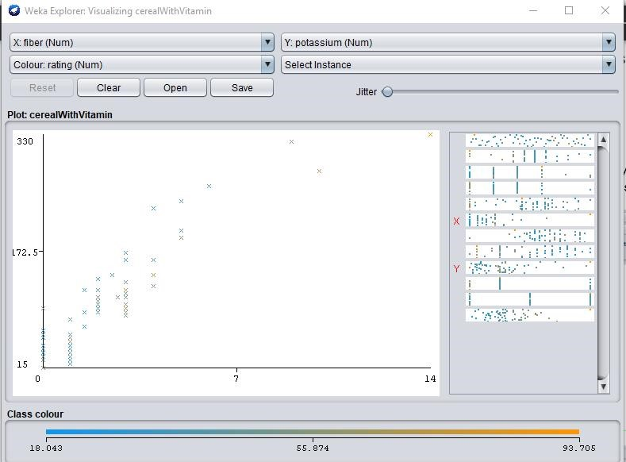

**2. Are groups of cereals from which we can choose according to our preferences?**

Ans: Yes, they are in groups so one can choose according to their own preferences.

* The diabetes patients can choose cereal from cluster -1
* Anyone looking for all food values he/she can choose a cereal from cluster two.
* Those who want high sodium, high potassium and high fiber can pick a cereal from cluster-11.
* Those who have both blood pressure and diabetics can chose from cluster-20
* Anyone looking for high sodium, high calories, low fat, low fiber, high potass can chose cluster-19

|  |  |  |
| --- | --- | --- |
| Type | Cluster No | Reason |
| Pregnant women | 2,12,14,16 | High fiber, High protein, high  calories. |
| High Pressure | 7,8,10,12,13 | Because of law sodium and fat |
| Low Pressure | 2.5,9,14 | Should take food containing High  sodium, high fiber, moderate fat |
| Diabetes | 1,2,7,10,12,13,14 | Needs to avoid sugar. |

* Anyone looking for high sodium, low fat, high calories can choose cluster-18 • Anyone looking for high calories, high carbon, low sugar can choose cluster-15

**3. See other correlation between the data given in the files.**

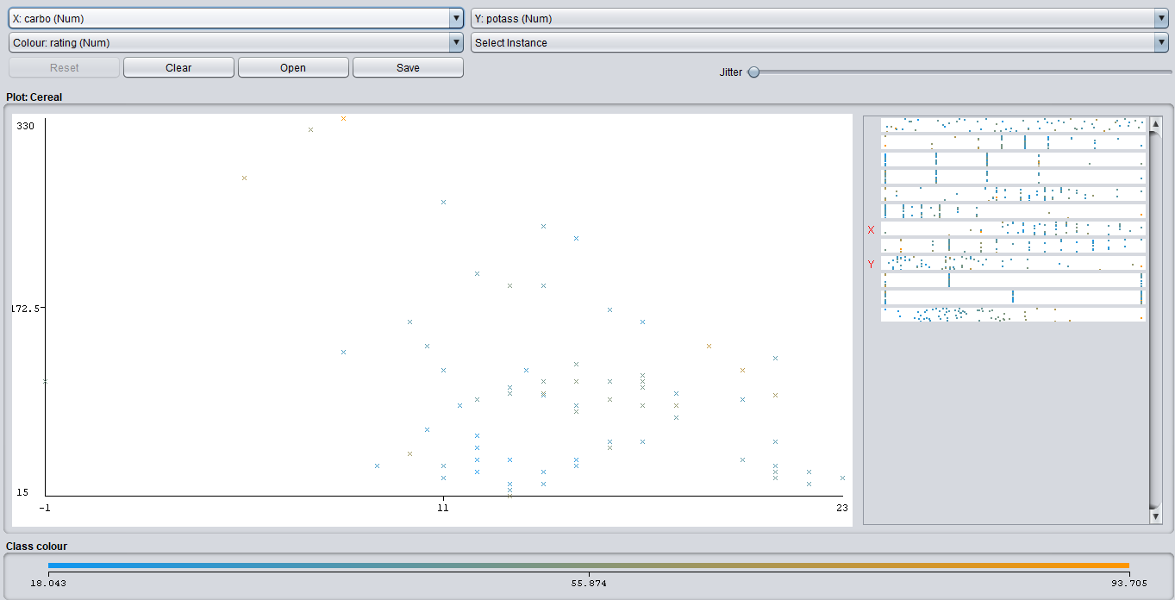Ans:

Here majority of the data indicates that complex carbohydrate is inversely proportional with potassium but not vice versa. That means when quantity of complex carbohydrate rises, potassium quantity decreases.

Here majority of the data indicates that complex carbohydrate is inversely proportional with potassium but not vice versa. That means when quantity of complex carbohydrate rises, potassium quantity decreases.